Assignment 2 (10%)
Due: March 11, 2019

The City Jail organization is preparing to deploy the new database to four departments. The departments and associated duties for the database are described in the following chart:

Department | No. of Employees | Duties
Criminal Records | 8 | - Add new criminals and crime charges  - Make changes to criminal and crime charge data as needed for corrections or updates.  - Keep the police officer information up to date.  - Maintain the crime codes list.
Court Recording | 7 | - Enter and modify all court appeals information.  - Enter and maintain all probation information.  - Maintain the probation officer list.
Crimes Analysis | 4 | - Analyze all criminal and court data to identify trends.  - Query all crimes data as needed to prepare federal and state reports.
Data officer | 1 | - Remove crimes, court, and probation data based on approved requests from any of the other departments.

Case Study: City Jail

Notes:
Use the tables you created in Assignment 1. They should have all the constraints as in Lab 4. The tables should have values as shown in Lab 5.
Lab 4
Case Study: City Jail

Notes:
This part of the case study addresses adding constraints to the City Jail database constructed in Chapter 3. Students need to reference the E-R model solution from Chapter 1 and the database descriptions from the Chapters 1 and 3 case study sections to determine all the constraints required. You need to give students details of the requirements. For example, the provided solution file assumes the following:
- Constraint naming: All constraints except NOT NULL constraints should be assigned a name.
- Foreign key columns: No NULL values should be allowed in FK columns except the Prob_ID column of the Sentences table because sentences aren’t always probation. If the sentence is not probation, the Prob_ID column is NULL.
To give students practice in both the CREATE TABLE and ALTER TABLE commands, the solution file also assumes the student is instructed to do the following:
- First, drop the APPEALS, CRIME_OFFICERS, and CRIME_CHARGES tables constructed in Chapter 3. These three tables are to be built last, using a CREATE TABLE command that includes all the necessary constraints.
- Second, use the ALTER TABLE command to add all constraints to the existing tables. Note that the sequence of constraint addition has an impact. Any tables referenced by FOREIGN KEYs must already have the PRIMARY KEY created.
- Third, use the CREATE TABLE command to build the three tables dropped in the first step.
Constraint list:

Table | Column | Constraint type | Condition
Aliases | Alias_ID | PRIMARY KEY
 | Criminal_ID | FOREIGN KEY | Ref Criminals table
 | Criminal_ID | NOT NULL
Criminals |  | PRIMARY KEY
 | V_status | CHECK | IN (‘Y’,’N’)
 | P_status | CHECK | IN (‘Y’,’N’)
Crimes | Crime_ID | PRIMARY KEY
 | Criminal_ID | FOREIGN KEY | Ref Criminals table
 | Criminal_ID | NOT NULL
 | Classification | CHECK | IN (‘F’,’M’,’O’,’U’)
 | Status | CHECK | IN (‘CL’,’CA’,’IA’)
Sentences | Sentence_ID | PRIMARY KEY
 | Criminal_ID | FOREIGN KEY | Ref Criminals table
 | Criminal_ID | NOT NULL
 | Prob_ID | FOREIGN KEY | Ref Prob_Officers table
 | Prob_ID | NOT NULL
 | Type | CHECK | IN (‘J’,’H’,’P’)
Prob_officers | Prob_ID | PRIMARY KEY
 | Status | CHECK | IN (‘A’,’I’)
Crime_charges | Charge_ID | PRIMARY KEY
 | Crime_ID | FOREIGN KEY | Ref Crimes Table
 | Crime_ID | NOT NULL
 | Crime_code | FOREIGN KEY | Ref Crime_codes table
 | Crime_code | NOT NULL
 | Charge_status | CHECK | IN(‘PD’,’GL’,’NG’)
Crime_officers | Crime_ID and Officer_ID | PRIMARY KEY
 | Crime_ID | FOREIGN KEY | Ref Crimes table
 | Officer_ID | FOREIGN KEY | Ref Officers table
Officers | Officer_ID | PRIMARY KEY
 | Status | CHECK | IN (‘A’,’I’)
Appeals | Appeal_ID | PRIMARY KEY
 | Crime_ID | FOREIGN KEY | Ref Crimes table
 | Crime_ID | NOT NULL
 | Status | CHECK | IN (‘P’,‘A’,’D’)
Crime_codes | Crime_code | PRIMARY KEY

Lab 5
Case Study: City Jail

1a.
INSERT INTO criminals (criminal_id, last, first, street, city, state, zip, phone, v_status, p_status)
VALUES (&id, '&last','& first','&street', '&city', '&state', '&zip', '&phone', '&v_status', '&p_status');

1b.
--use script from 1a.

1c.
ALTER TABLE criminals
ADD (mail_flag CHAR(1));

1d.
UPDATE criminals
SET mail_flag = 'Y';

1e.
UPDATE criminals
SET mail_flag = 'N'
WHERE street IS NULL;

1f.
UPDATE criminals
SET phone = '7225659032'
WHERE criminal_id = 1016;

1g.
DELETE FROM criminals
WHERE criminal_id = 1017;

2a.
INSERT INTO crimes (crime_id, criminal_id, classification, date_charged, status)
VALUES (100, 1010, 'M', '15-JUL-09', 'PD');
--FK violation - criminal id OR check violation - status

2b.
INSERT INTO crimes (crime_id, criminal_id, classification, date_charged, status)
VALUES (130, 1016, 'M', '15-JUL-09', 'PD');
--Check violation - status

2c.
INSERT INTO crimes (crime_id, criminal_id, classification, date_charged, status)
VALUES (130, 1016, 'P', '15-JUL-09', 'CL');
--Check violation - classification

This project should provide a good source for discussion. For example, given the Data Officer duty of data removal, should any of the other departments be assigned delete privileges for data modification duties? Also, do users who need to modify or update data need the SELECT privilege? Do they need to query data first to locate existing records?

Department | Privileges Needed
Criminal Records | CREATE SESSION, SELECT, INSERT, UPDATE  ON criminals, crimes, crime_charges, aliases, officers, crime_codes
Court Recording | CREATE SESSION, SELECT, INSERT, UPDATE  ON appeals, sentences, prob_officers
Crimes Analysis | CREATE SESSION, SELECT ANY TABLE
Data Officer | CREATE SESSION, SELECT, DELETE  ON crimes, sentences, appeals, crime_charges

QUESTION 1:

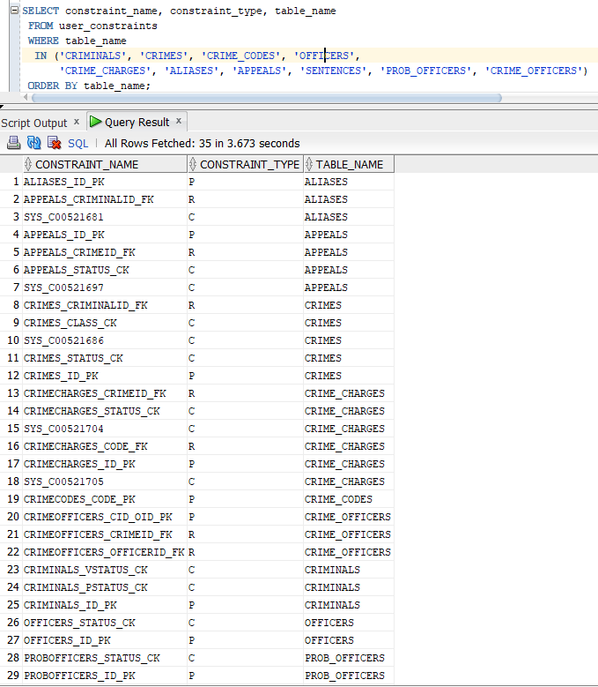
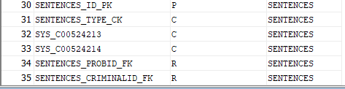

QUESTION 2:

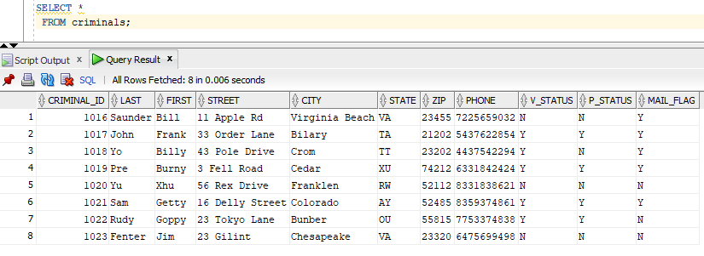

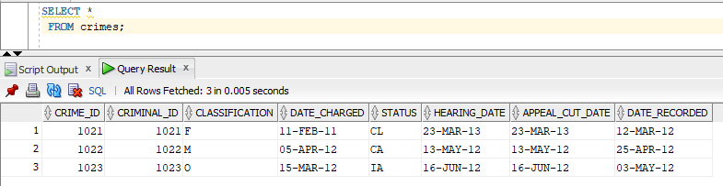

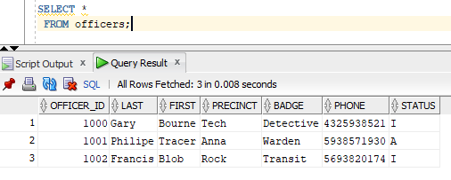

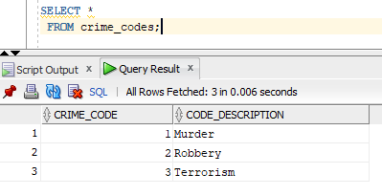

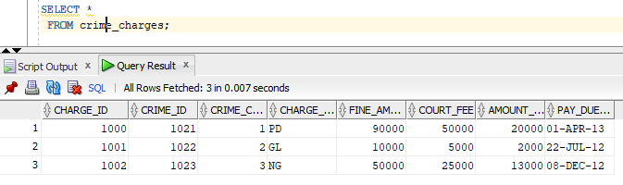

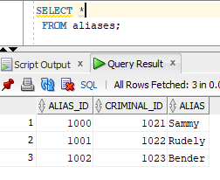

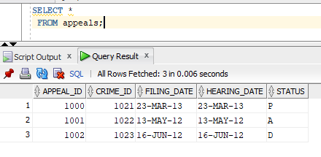

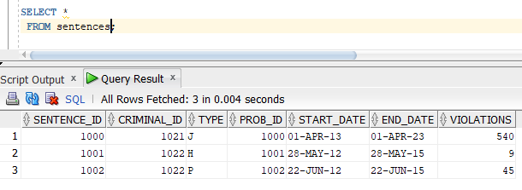

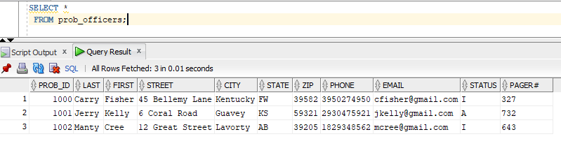

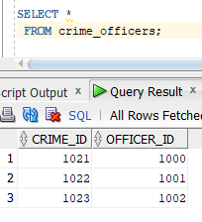

QUESTION 3:

Criminal Records Department
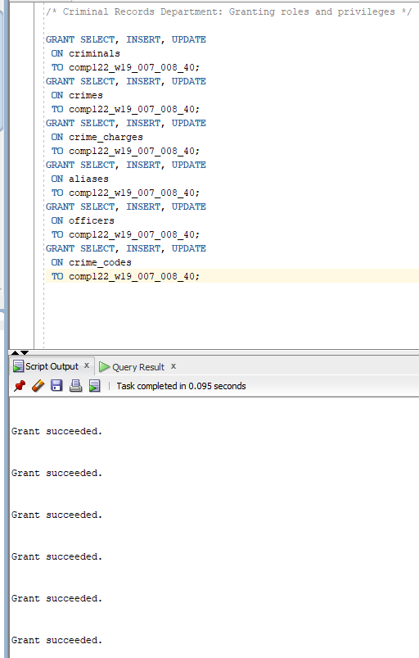
Court Recording Department
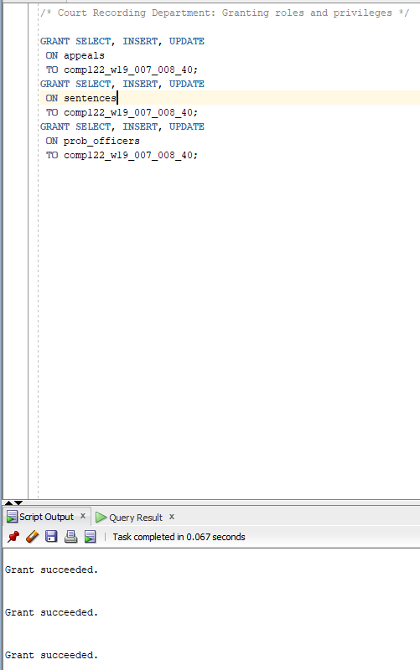

Crimes Analysis Department
Data Officer Department

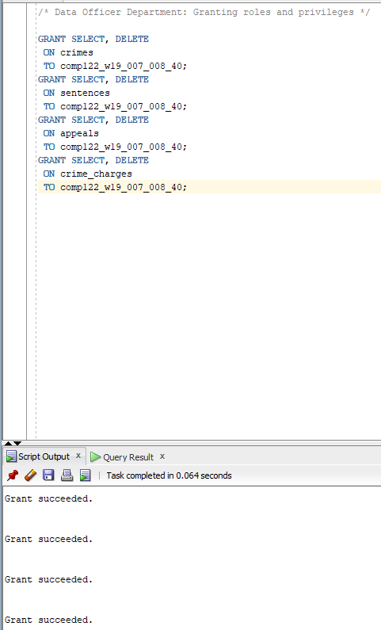

QUESTION 4:

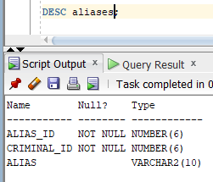

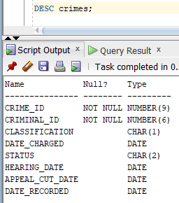

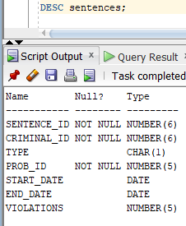

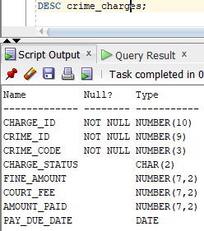

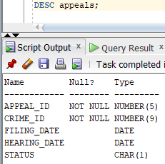

QUESTION 5:

